Enables…



GoogleMap Editor



Umbraco 6

1. An easy way to create and store maps in Umbraco

This package allows you to add, store and customize single or multiple locations, regions, routes... thanks GoogleMaps API v3.0.

It is using the full set of drawing tool from GoogleMaps API which enables adding and editing of following to a map:

* Pins (Markers)
* Circles
* Polygons
* Polylines
* Rectangles

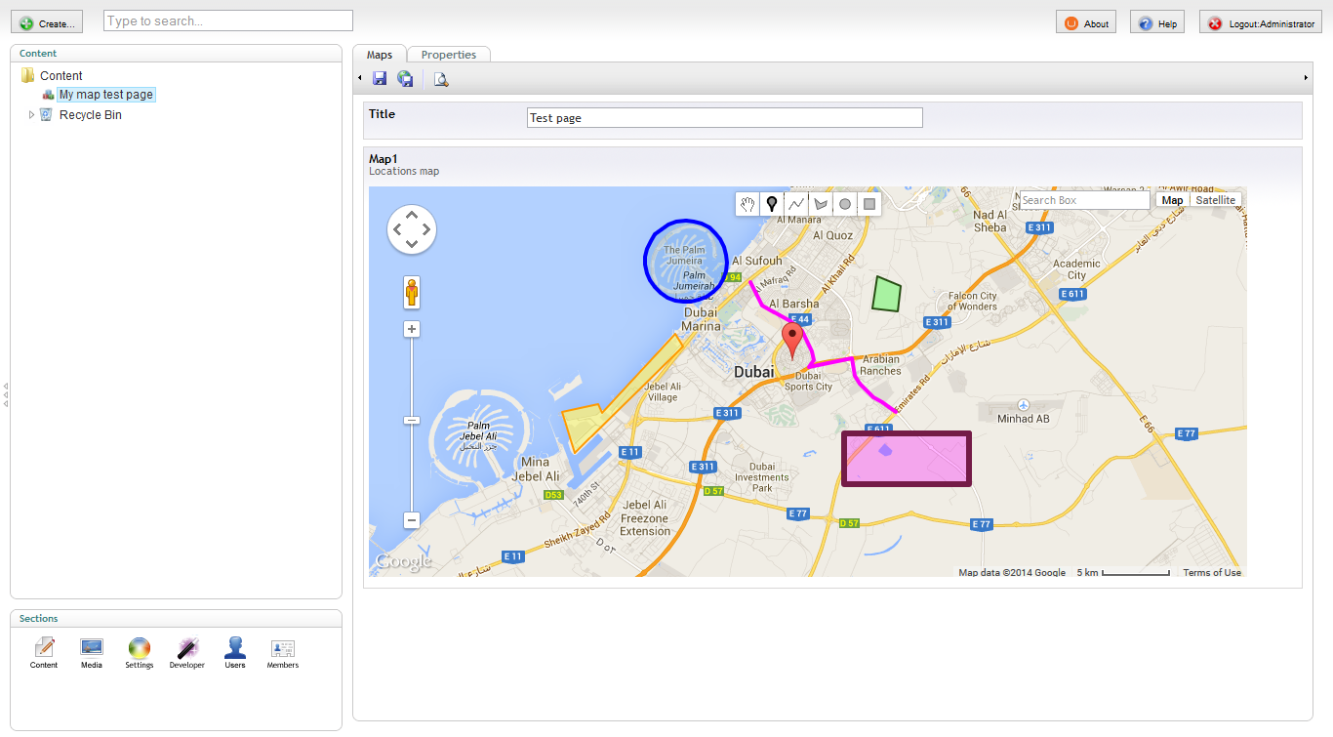

1. Customize editor layout

You can declare multiple data types with this editor and adapter each and every to the needs of document you are applying it to thanks to built in advanced and easy to use configuration interface.

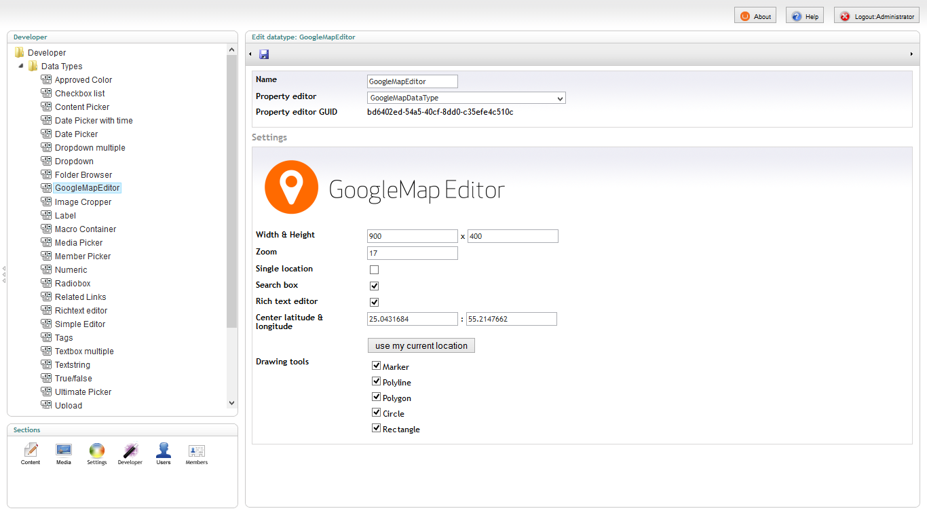

1. Fast implementation on your website

As soon as package is installed you will have it available in Developer section under DataTypes as GoogleMapEditor.

The package comes with sample partial view which you can use to display your stored maps. In no time you will have you map on your published page.

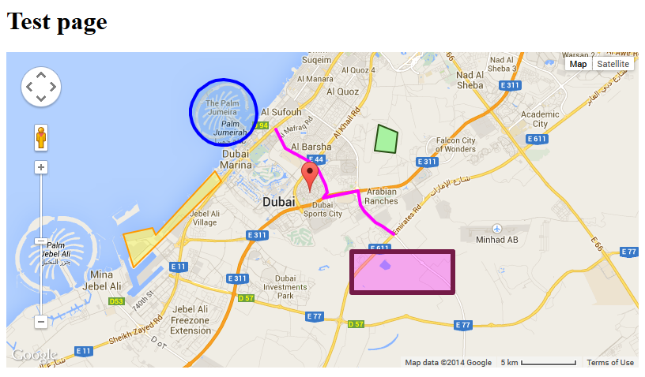

1. Participate in improving it

This package source code is hosted at GitHub.   
Feel free to fork it, improve it, suggest functionalities or report issues. The repository URL on GitHub is <https://github.com/dejanstojanovic/Umbraco-GoogleMap-Editor>

Checkout **HowTo** document for more info